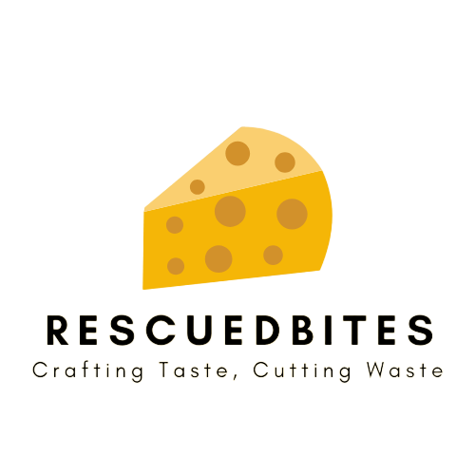**Project Based Learning: Project Report**

(Vardan S Kamra, Saksham Negi, Lakshya Khandelwal, Poorak)

**Project Objectives:**

* **Raise Awareness:** The primary objective of the RescuedBites project is to raise awareness about the global issue of food waste and its economic, environmental, and social impacts.
* **Cost Savings:** Help users save money by making informed decisions about their food consumption, avoiding unnecessary purchases, and utilizing ingredients efficiently.
* **Contribution to Sustainability:** Encourage and enable users to contribute to a sustainable future by actively participating in reducing food waste.

**Project Description:**

Food waste is a pressing global issue with far-reaching economic, environmental, and social consequences. Every year, a staggering 1.3 billion tons of food is wasted, depleting valuable resources and contributing to harmful greenhouse gas emissions. The RescuedBites project aims to address this problem by providing an accessible and user-friendly platform for efficient food waste management.

**Project Methodology:**